EXEMPLAR LESSON PLAN
ECD/FP: Grade R
TERM 3


DAILY PLANNER

Term : | 3 | Theme: | Water
Day: | 1 | Date:

ARRIVAL AND FREE PLAY |  | Free play outside
MORNING RING  THEME DISCUSSION  (15MIN) |  | Greeting, Register, Devotion, Weather Chart, Birthdays, News.
TEACHERS GUIDED ACTIVITY - LIFE SKILLS CAPS p.19
Discuss items on the theme table. Where does water come from? When it rains we get water. You find water in lakes, rivers and ocean. The water in the ocean is salty.
Free Play inside
MATHEMATICS  (50 MIN) | Mental Maths/ Oral Counting:  Focus Activity  Day 1: Whole class Teacher Guided activities.  (15-25min) |  |  | TEACHERS GUIDED ACTIVITY - MATHEMATICS CAPS p. 176 - 180  - Song: Sing the song, Seven green speckled frogs.  - Oral counting: 1–20 and 10–1.  - Counting objects 1–10: Learners stand in a circle. Call out a number between 1 and 10. Learners take turns to bounce the ball according to the number called. Together count the number of bounces.  - Reinforce the circle, square, triangle: Draw a large circle, square and triangle on the floor. Learners walk along the edges of the shapes.  When the music stops, they step into the shape they are walking on.  - Introducing rectangles: Trace around the face of a large rectangle shaped box to draw a rectangle. Focus on the straight lines, the corners and the number of sides while drawing.
MATHEMATICS  (50 MIN) | Teacher Guided Activity:  (25-30min)  Focus group  Blue group |  |  | 1. Counting objects 1–10: Learners count out 10 attribute blocks from their tubs.  - Practising shapes: Learners sort their attribute blocks according to their similarities and differences. They place them in the correct column on their shape sorting page.  - Dot cards (1–7): Give each learner a dot card. They take turns to use their fruit counters and copy the dot arrangements on their cards. Check each learner’s arrangement before giving them new cards.  Check that learners are able to:  . Count 10 objects  . Identify and copy arrangement of objects (1-7) to dot cards  . Apply a line of symmetry in shapes  . Recognize and name rectangles and describe their properties  Assessment
MATHEMATICS  (50 MIN) | Green group |  |  | Workstation 1: Learners complete the shape in the picture so that both sides are the same, which makes the shape symmetrical. They colour the two sides using two different colours.
MATHEMATICS  (50 MIN) | Yellow group |  |  | Workstation 2: Learners copy or trace the individual shapes and draw a picture using all the shapes
MATHEMATICS  (50 MIN) | Red group |  |  | Workstation 3: Learners paste rectangle shapes onto paper to make a rectangle person.
MATHEMATICS  (50 MIN) | Purple group |  |  | Workstation 4: Learners build puzzles.
FOCUS: LIFE SKIILLS CREATIVE ART/ PERCEPTUAL/ SCIENCE  (15min) | Focus Activity  Green group |  |  | Create in 2D: Draw and paint freely using the week’s topic.Working in different formats and paper sizes and brushes of different sizes to work with increased detail . Learners make an ocean aquarium: Use paper plate paint half of the plate blue and put sand on the other half colour, cut and paste the fishes and seaweed.  Science: Ask learners what will happen when we mix sugar with water? Let each learner throw a little bit of sugar in the water. Mix rice with water it will also dissolve, explore with different objects? Explore things that sink or float.  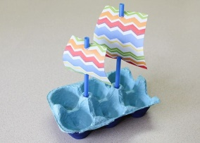  Create in 3D (Constructing and modeling)  Encourage development of skills through manipulation of the materials  Learners make their own boat using egg trays, straws and cardboard, or any  other waist material that can be used.  Learners can make their own octopus using a paper plate and strings of papers  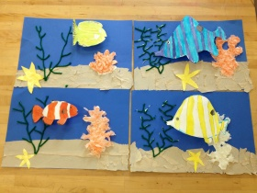  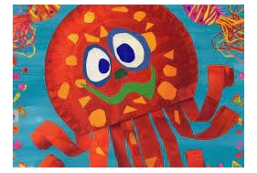
 | Yellow group |  |  | Side Activity 1:Educational toys
 | Red group |  |  | Side Activity 2:Strings and beads
 | Purple group |  |  | Side Activity 3: Cutting activity: Playdough
 | Blue group |  |  | Side Activity 4: Fantasy corner
PHYSICAL EDUCATION:  (42min) |   1 x Focus activity  4 x Wellness2life Programme & 4 Independent Workstations  TEACHER GUIDED ACTIVITY – PHYSICAL EDUCATION: CAPS: p. 28  Locomotor: Non-locomotor: bending, stretching and curling the body into various shapes  Perceptual motor: Jump over low obstacles such as low held rope  Balance: Identify different ways of moving across balancing beams, jump off and soft landing (bend the knees)  Spatial orientation: Jump over and move under obstacles, crawling, climbing, jumping, etc.
TEACHERS GUIDED ACTIVITY–HOME LANGUAGE CAPS 43 – 47 (Language Activity Guide Term 2 Grade R Language Improvement Program. 36 – 42) 30min)
LANGUAGE RING  LISTENING AND SPEAKING  EMERGENT READING  EMERGENT WRITING  Small Group Activities ( Refer to Activity Guide Term 3 page 41- 42 for steps) |  | SONG: Sam and Zinzi went shopping, went shopping, went shopping;  Sam and Zinzi went shopping to buy their Mama’s food.  Spot, the doggie, went with them, went with them, went with them;  Spot, the doggie, went with them to see what he could find.  When they got back home again, home again, home again;  When they got back home again, Mommy said: “Where is Spot?”  Musa kindly brought Spot back, brought Spot back, brought Spot back;  Musa kindly brought Spot back, they all said: “Thank you, Musa!” | Phonic:  High frequency words: |  |  | Phonic sound: “o”  High frequent word: “what”
 |  |  | Vocabulary for the story: |  |  | Jam, eggs, butter, bread, milk, crumbs
 |  |  | Story: |  |  | Title: Spot goes to the shop
 |  |  | Whole Class:  (Story Base)  Whole Class:  (Letter & Sound) |  |  | More sequencing pictures  1. Begin with learners sitting on the mat. Choose learners to stand in front of the class, each holding one of the colour sequence pictures (not in the correct order).  2. Ask learners if the pictures are in the correct order. Ask them to point out the picture which should be at the beginning of the story.  3. Together as a group, ask learners who are holding the pictures to move around until the story makes sense. Ask questions such as: “Who can remember what happened next?”  4. Once you have sequenced the story, learners must move to their tables.  5. Give each learner a little book. Encourage them to look at the cover and read the title of the story with them.  6. Take learners on a picture walk through the little book, helping them to notice that the pictures in the book are the same as the sequence pictures.  7. If there is time, learners can “read” their little book to a partner in the class.  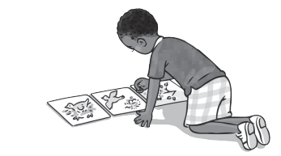Encourage learners to take the books home to read with their families.  Introducing a sound from the story  1. Ask learners to sit on the mat and listen carefully to you. Say these words from the story: “dog, Spot, shop, knock, not. Can you hear the focus sound: dog, Spot, shop, knock? Yes, you are right! The focus sound is /o/.”  2. “Listen carefully, here are some more words with /o/: on, orange, office, ostrich, octopus.” (Emphasise the focus sound as you say these words.)  3. Say the sound /o/ clearly and tell learners to watch your mouth carefully.  4. Ask learners to say the sound /o/: “o-o-o”. Make this fun: Say it softly, loudly, to the wall, to the ceiling and to each other. Make sure learners are saying the sound of the letter and not the letter name, o (“oh”).
 |  |  | Blue group |  | Activity 1: Draw and Emergent writing
 |  |  | Green group |  | Activity 5: Pretend Play
 |  |  | Yellow group |  | Activity 4: Fine motor skills and handwriting
 |  |  | Red group |  | Activity 3: Independent Reading
 |  |  | Purple group |  | Activity 2: Puzzle and games
Story Every day 20min |  | For fun and relaxation- different from the Home language story focus for the week

EXEMPLAR LESSON PLAN
ECD/FP: Grade R TERM 3

DAILY PLANNER
Term : | 3 | Theme: | Water
Day: | 2 | Date:

ARRIVAL AND FREE PLAY |  | Free play outside
MORNING RING  THEME DISCUSSION  (15MIN) |  | Greeting, Register, Devotion, Weather Chart, Birthdays, News.
TEACHERS GUIDED ACTIVITY - LIFE SKILLS CAPS p.19
All living things (plants and animals) need water to live. We drink water every day. Fish live in water. What happens if you forget to water the plants?
Free Play inside
MATHEMATICS  (50 MIN | Mental Maths/ Oral Counting:  Focus Activity  Day 2: Whole class Teacher Guided activities.  (15-25min |  | TEACHERS GUIDED ACTIVITY - MATHEMATICS CAPS p. 176 - 180  1.Song: Sing the song, It’s a rectangle. Show a picture of a rectangle and point to the sides as learners sing.  2.Oral counting: 1–20 and 10–1.  3.Counting objects 1–10: Ten learners form a circle with ten chairs. Each learner stands up and says a number starting from 1 and then sits down. When the last learner sits the whole class says ‘10’. Repeat the activity, starting with a different learner.  4.Rectangle hunt: Learners play the game, ‘I spy … a rectangle.’ Learners guess where the rectangle is in the classroom, for example, pictures, or rectangular shapes, such as the door, window, table, books. Learners predict what rectangle shapes they might find outside and go on a rectangle hunt.  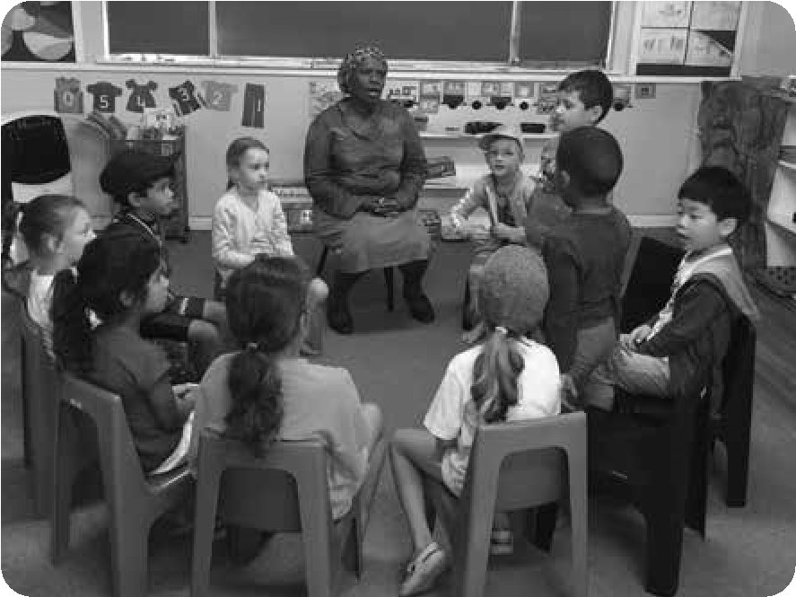  a hat.
MATHEMATICS  (50 MIN | Teacher Guided Activity:  Focus group  (25-30min)  Green group |  | - Counting objects 1–10: Learners count out 10 attribute blocks from their tubs.  - Practising shapes: Learners sort their attribute blocks according to their similarities and differences. They place them in the correct column on their shape sorting page.  - Dot cards (1–7): Give each learner a dot card. They take turns to use their fruit counters and copy the dot arrangements on their cards. Check each learner’s arrangement before giving them new cards.  Check that learners are able to:  . Count 10 objects  . Identify and copy arrangement of objects (1-7) to dot cards  . Apply a line of symmetry in shapes  . Recognize and name rectangles and describe their properties  Assessment
MATHEMATICS  (50 MIN | Yellow group |  | Workstation 1: Learners complete the shape in the picture so that both sides are the same, which makes the shape symmetrical. They colour the two sides using two different colours.
MATHEMATICS  (50 MIN | Red group |  | Workstation 2: Learners copy or trace the individual shapes and draw a picture using all the shapes
MATHEMATICS  (50 MIN | Purple group |  | Workstation 3: Learners paste rectangle shapes onto paper to make a rectangle person.
MATHEMATICS  (50 MIN | Blue group |  | Workstation 4: Learners build puzzles.
FOCUS: LIFE SKIILLS CREATIVE ART/ PERCEPTUAL/ SCIENCE  (15min) | Focus Activity:  Yellow group |  | Create in 2D: Draw and paint freely using the week’s topic. Working in different formats and paper sizes and brushes of different sizes to work with increased detail . Learners make an ocean aquarium: Use paper plate paint half of the plate blue and put sand on the other half colour, cut and paste the fishes and seaweed.  Science: Ask learners what will happen when we mix sugar with water? Let each learner throw a little bit of sugar in the water. Mix rice with water it will also dissolve, explore with different objects? Explore things that sink or float  Encourage development of skills through manipulation of the materials  Learners make their own boat using egg trays, straws and cardboard, or any  other waist material that can be used.  Learners can make their own octopus using a paper plate and strings of papers  DBE Workbook  Assessment
 | Red group |  | Side Activity 1:Educational toys
 | Purple group |  | Side Activity 2:Strings and beads
 | Blue group |  | Side Activity 3: Cutting activity: Playdough
 | Green group |  | Side Activity 4: Fantasy corner
PHYSICAL EDUCATION:  (42min) | 1 x Focus activity  4 x Wellness2life Programme & 4 Independent Workstations  TEACHER GUIDED ACTIVITY – PHYSICAL EDUCATION: CAPS: p. 28  Locomotor: Non-locomotor: bending, stretching and curling the body into various shapes  Perceptual motor: Jump over low obstacles such as low held rope  Balance: Identify different ways of moving across balancing beams, jump off and soft landing (bend the knees)  Spatial orientation: Jump over and move under obstacles, crawling, climbing, jumping, etc.
TEACHERS GUIDED ACTIVITY–HOME LANGUAGE CAPS 43 – 47 (Language Activity Guide Term 2 Grade R Language Improvement Program. 36 – 42) 30min)
LANGUAGE RING  LISTENING AND SPEAKING  EMERGENT READING  EMERGENT WRITING  Small Group Activities ( Refer to Activity Guide Term 3 page 41- 42 for steps) |  | SONG: Sam and Zinzi went shopping, went shopping, went shopping;  Sam and Zinzi went shopping to buy their Mama’s food.  Spot, the doggie, went with them, went with them, went with them;  Spot, the doggie, went with them to see what he could find.  When they got back home again, home again, home again;  When they got back home again, Mommy said: “Where is Spot?”  Musa kindly brought Spot back, brought Spot back, brought Spot back;  Musa kindly brought Spot back, they all said: “Thank you, Musa!” |  | Phonic:  High frequency words: |  | Phonic sound: “o”  High frequent word: “what”
 |  |  |  | Vocabulary for the story: |  | Jam, eggs, butter, bread, milk, crumbs
 |  |  |  | Story: |  | Title: Spot goes to the shop
 |  |  |  | Whole Class:  (Story Base)  Whole Class:  (Letter & Sound)  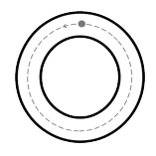 |  | Shared reading – Big Book  1 Encourage learners to look at the cover picture and talk about what they see and recognise.  2 Read the title of the story to the class. Point to each word as you read. Read it again and ask learners to read with you.  3 Take learners on a picture walk through the book, discussing the pictures and encouraging learners to ask questions.  4 Point out the page numbers and talk about what number will come next.  5 When you have “walked” through the whole book, go back to the beginning and read the title again. Then turn the pages and read each sentence in a clear and natural voice. Point to each word as you read.  6 Read the book again and encourage learners to “read” with you.  Forming the letter  1. Remind learners of the focus sound. Ask learners if anyone’s name starts with /o/ or if they can think of any other words that start with the sound /o/.  2. Teach learners an action associated with the sound. For example: Learners can pretend they are turning a light on and say “o, o, o, on”.  3. Show learners how to write the letter o. Praise their attempts, then write a large  letter on the board or in the air while saying the following: “Start at the dot, go around.”  4. Let learners practise the letter formation in the air, on the carpet, on each other’s backs or on their hands. They can also try using their bodies to make the letter.  5. Once you have modelled how to write the letter, go outside and give each learner a container with water and a paintbrush. Learners can paint a letter many times in water on the paving.  6 Encourage learners to say the sound the letter makes as they write the letter
 |  |  |  | Green group | Activity 2: Puzzle and games
 |  |  |  | Yellow group | Activity 1: Draw and Emergent writing
 |  |  |  | Red group | Activity 5: Pretend Play
 |  |  |  | Purple group | Activity 4: Fine motor skills and handwriting
 |  |  |  | Blue group | Activity 3: Independent Reading
Story Every day 20min |  | For fun and relaxation- different from the Home language story focus for the week

EXEMPLAR LESSON PLAN
ECD/FP: Grade R
TERM 3

DAILY PLANNER
Term : | 3 | Theme: | Water
Day: | 3 | Date:

ARRIVAL AND FREE PLAY | Free play outside
MORNING RING  THEME DISCUSSION  (15MIN) | Greeting, Register, Devotion, Weather Chart, Birthdays, News.
MORNING RING  THEME DISCUSSION  (15MIN) | TEACHERS GUIDED ACTIVITY - LIFE SKILLS CAPS p.19  What happens when we mix sugar with water? It dissolves. Do you think if we mix rice with water it will also dissolve? Explore things that sink or float.
Free Play inside
MATHEMATICS  (50 MIN) |  | Mental Maths/ Oral Counting:  Focus Activity  Day 3: Whole class Teacher Guided activities.  (15-25min | TEACHERS GUIDED ACTIVITY - MATHEMATICS CAPS p. 176 - 180  1. Song: Sing the song, Looby loo.  2. Oral counting: 1–20 and 10–1.  - Counting objects 1–10: Learners sit in a circle. They count ten objects as you place them in the bag. They pass the bag around as music plays. When the music stops the learner holding the bag puts one or more objects from the bag into the middle of the mat. Other learners guess how many objects there are on the mat. Together count these. Repeat the activity.  - Practising shapes: Learners look for square and rectangular blocks in the classroom. They compare the differences and similarities between these. They place the blocks on the cardboard rectangle or square, as appropriate.  - Identifying shapes: Discuss Poster 3.
 |  | Teacher Guided Activity:  Focus group  (25-30min)  Yellow group: | 1. Counting objects 1–10: Learners count out 10 attribute blocks from their tubs.  - Practising shapes: Learners sort their attribute blocks according to their similarities and differences. They place them in the correct column on their shape sorting page.  - Dot cards (1–7): Give each learner a dot card. They take turns to use their fruit counters and copy the dot arrangements on their cards. Check each learner’s arrangement before giving them new cards.  Check that learners are able to:  . Count 10 objects  . Identify and copy arrangement of objects (1-7) to dot cards  . Apply a line of symmetry in shapes  . Recognize and name rectangles and describe their properties  Assessment  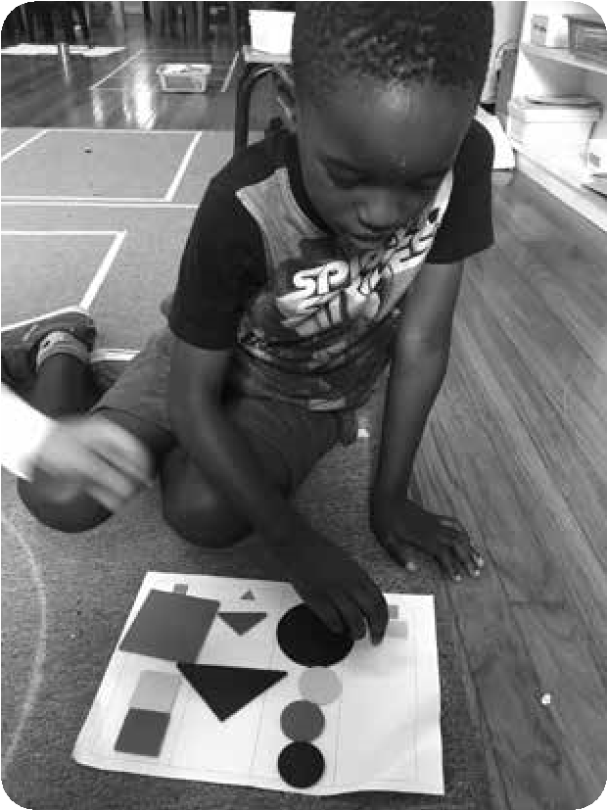
 |  | Red group | Workstation 1: Learners complete the shape in the picture so that both sides are the same, which makes the shape symmetrical. They colour the two sides using two different colours.
 |  | Purple group | Workstation 2: Learners copy or trace the individual shapes and draw a picture using all the shapes
 |  | Blue group | Workstation 3: Learners paste rectangle shapes onto paper to make a rectangle person.
 |  | Green group | Workstation 4: Learners build puzzles.
FOCUS: LIFE SKIILLS CREATIVE ART/ PERCEPTUAL/ SCIENCE  (15min) |  | Focus Activity:  Red group | Create in 2D: Draw and paint freely using the week’s topic. Working in different formats and paper sizes and brushes of different sizes to work with increased detail . Learners make an ocean aquarium: Use paper plate paint half of the plate blue and put sand on the other half colour, cut and paste the fishes and seaweed.  Science: Ask learners what will happen when we mix sugar with water? Let each learner throw a little bit of sugar in the water. Mix rice with water it will also dissolve, explore with different objects? Explore things that sink or float  Encourage development of skills through manipulation of the materials  Learners make their own boat using egg trays, straws and cardboard, or any  other waist material that can be used.  Learners can make their own octopus using a paper plate and strings of papers  DBE Workbook  Assessment
 |  | Purple group | Side Activity 1:Educational toys
 |  | Blue group | Side Activity 2:Strings and beads
 |  | Green group | Side Activity 3: Cutting activity: Playdough
 |  | Yellow group | Side Activity 4: Fantasy corner
PHYSICAL EDUCATION:  (42min) |  | 1 x Focus activity  4 x Wellness2life Programme & 4 Independent Workstations  TEACHER GUIDED ACTIVITY – PHYSICAL EDUCATION: CAPS: p. 28  Locomotor: Non-locomotor: bending, stretching and curling the body into various shapes  Perceptual motor: Jump over low obstacles such as low held rope  Balance: Identify different ways of moving across balancing beams, jump off and soft landing (bend the knees)  Spatial orientation: Jump over and move under obstacles, crawling, climbing, jumping, etc.
TEACHERS GUIDED ACTIVITY–HOME LANGUAGE CAPS 43 – 47 (Language Activity Guide Term 2 Grade R Language Improvement Program. 36 – 42) 30min)
LANGUAGE RING  LISTENING AND SPEAKING  EMERGENT READING  EMERGENT WRITING  Small Group Activities ( Refer to Activity Guide Term 3 page 41- 42 for steps) | SONG: Sam and Zinzi went shopping, went shopping, went shopping;  Sam and Zinzi went shopping to buy their Mama’s food.  Spot, the doggie, went with them, went with them, went with them;  Spot, the doggie, went with them to see what he could find.  When they got back home again, home again, home again;  When they got back home again, Mommy said: “Where is Spot?”  Musa kindly brought Spot back, brought Spot back, brought Spot back;  Musa kindly brought Spot back, they all said: “Thank you, Musa!” |  |  | Phonic:  High frequency words: |  | Phonic sound: “o”  High frequent word: “what”
 |  |  |  | Vocabulary for the story: |  | Jam, eggs, butter, bread, milk, crumbs
 |  |  |  | Story: |  | Title: Spot goes to the shop
 |  |  |  | Whole Class:  (Story Base)  Whole Class:  (Letter & Sound) |  | Learning to listen  1. Seat learners in a circle and settle everyone down so that the class is quiet and calm.  2. Now pick up four items of food or pictures of food and name each one. After showing learners the items, put them behind your back and ask if anyone can remember what you showed them. Listen to their responses, and then repeat the activity with five items.  3. Start a story: “The children went to the shop to buy butter.”  4. The next learner in the circle must add another item of food: “The children went to the shop to buy butter and sugar.”  5. The next learner in the circle adds another: “The children went to the shop to buy butter and sugar and soap …” Keep it to a maximum of five items in the list; start again after five learners.  Letter boxes  1. Ask learners to sit on the mat and show them the objects and pictures in the letter box one at a time. Let them hold the objects or pictures and pass them around.  2. Discuss each picture or object, talking about the colour and emphasising the word ‘orange’ and the sound ‘o’. Explain to learners that the word orange is a colour but is also the name of a fruit!  3. Say to learners that you are going to describe something in the box and they must guess what it is. Put your hand in the letter box and say: “I have something that is orange and I use it to wash my body (soap), I have something that is orange and I use it to write my name (crayon)”.  4. Give each learner a piece of orange. They must say the focus sound ‘o’ for orange and then taste their orange and say what it tastes like – sweet, sour, soft, juicy.  5. Use a mirror so that learners can see how their mouths move when they make the sound. Show them how to shape their mouth when they say ‘o’, and how to form the shape of the letter with their hands.  6. Once learners have practised the new sound, show them the letter on the letter box. Let some learners trace over the letter on the lid with their fingers.
 |  |  |  | Yellow group | Activity 3: Independent Reading
 |  |  |  | Red group | Activity 2: Puzzle and games
 |  |  |  | Purple group | Activity 1: Draw and Emergent writing
 |  |  |  | Blue group | Activity 5: Pretend Play
 |  |  |  | Green group | Activity 4: Fine motor skills and handwriting

EXEMPLAR LESSON PLAN
ECD/FP: Grade R
TERM 3

DAILY PLANNER
Term : | 3 | Theme: | Water
Day: | 4 | Date:

ARRIVAL AND FREE PLAY | Free play outside
MORNING RING  THEME DISCUSSION  (15MIN) | Greeting, Register, Devotion, Weather Chart, Birthdays, News.
MORNING RING  THEME DISCUSSION  (15MIN) | TEACHERS GUIDED ACTIVITY - LIFE SKILLS CAPS p.19  We can measure water in a bottle, jug, glass or even a spoon. Use different glasses filled with water. Which glass has the most water
Free Play inside
MATHEMATICS  (50 MIN) |  | Mental Maths/ Oral Counting:  Focus Activity  Day 4: Whole class Teacher Guided activities.  (15-25min | TEACHERS GUIDED ACTIVITY - MATHEMATICS CAPS p. 176 - 180  1. Song: Sing the song, Looby loo.  2. Oral counting: 1–20 and 10–1.  - Counting objects 1–10: Five learners stand around the six hula hoops. Play music. When the music stops, learners place the number of body parts you say over the hoop. For example: ‘Show me five heads, ten elbows, four feet, nine fingers.’  - Position and direction: Place a loose elastic/wool band on each learner’s right hand.
 |  | Teacher Guided Activity:  Focus group  Red group | 1. Counting objects 1–10: Learners count out 10 attribute blocks from their tubs.  - Practising shapes: Learners sort their attribute blocks according to their similarities and differences. They place them in the correct column on their shape sorting page.  - Dot cards (1–7): Give each learner a dot card. They take turns to use their fruit counters and copy the dot arrangements on their cards. Check each learner’s arrangement before giving them new cards.  Check that learners are able to:  . Count 10 objects  . Identify and copy arrangement of objects (1-7) to dot cards  . Apply a line of symmetry in shapes  . Recognize and name rectangles and describe their properties  Assessment
 |  | Purple group | Workstation 1: Learners complete the shape in the picture so that both sides are the same, which makes the shape symmetrical. They colour the two sides using two different colours.
 |  | Blue group | Workstation 2: Learners copy or trace the individual shapes and draw a picture using all the shapes
 |  | Green group | Workstation 3: Learners paste rectangle shapes onto paper to make a rectangle person.
 |  | Yellow group | Workstation 4: Learners build puzzles.
FOCUS: LIFE SKIILLS CREATIVE ART/ PERCEPTUAL/ SCIENCE  (15min) |  | Focus Activity: Purple group | Create in 2D: Draw and paint freely using the week’s topic. Working in different formats and paper sizes and brushes of different sizes to work with increased detail . Learners make an ocean aquarium: Use paper plate paint half of the plate blue and put sand on the other half colour, cut and paste the fishes and seaweed.  Science: Ask learners what will happen when we mix sugar with water? Let each learner throw a little bit of sugar in the water. Mix rice with water it will also dissolve, explore with different objects? Explore things that sink or float  Encourage development of skills through manipulation of the materials  Learners make their own boat using egg trays, straws and cardboard, or any  other waist material that can be used.  Learners can make their own octopus using a paper plate and strings of papers  DBE Workbook  Assessment
 |  | Blue group | Side Activity 1:Educational toys
 |  | Red group | Side Activity 2:Strings and beads
 |  | Green group | Side Activity 3: Cutting activity: Playdough
 |  | Yellow group | Side Activity 4: Fantasy corner
PHYSICAL EDUCATION:  (42min) |  | 1 x Focus activity  4 x Wellness2life Programme & 4 Independent Workstations  TEACHER GUIDED ACTIVITY – PHYSICAL EDUCATION: CAPS: p. 28  Locomotor: Non-locomotor: bending, stretching and curling the body into various shapes  Perceptual motor: Jump over low obstacles such as low held rope  Balance: Identify different ways of moving across balancing beams, jump off and soft landing (bend the knees)  Spatial orientation: Jump over and move under obstacles, crawling, climbing, jumping, etc.
TEACHERS GUIDED ACTIVITY–HOME LANGUAGE CAPS 43 – 47 (Language Activity Guide Term 2 Grade R Language Improvement Program. 36 – 42) 30min)
LANGUAGE RING  LISTENING AND SPEAKING  EMERGENT READING  EMERGENT WRITING  Small Group Activities ( Refer to Activity Guide Term 3 page 41- 42 for steps) | SONG: Sam and Zinzi went shopping, went shopping, went shopping;  Sam and Zinzi went shopping to buy their Mama’s food.  Spot, the doggie, went with them, went with them, went with them;  Spot, the doggie, went with them to see what he could find.  When they got back home again, home again, home again;  When they got back home again, Mommy said: “Where is Spot?”  Musa kindly brought Spot back, brought Spot back, brought Spot back;  Musa kindly brought Spot back, they all said: “Thank you, Musa!” |  |  | Phonic:  High frequency words: |  | Phonic sound: “o”  High frequent word: “what”
 |  |  |  | Vocabulary for the story: |  | Jam, eggs, butter, bread, milk, crumbs
 |  |  |  | Story: |  | Title: Spot goes to the shop
 |  |  |  | Whole Class:  (Story Base)  Whole Class:  (Letter & Sound) |  | Sequencing pictures  Read and do  1 Tell learners to look through the shopping brochure.  2 Encourage learners to “read” the labels and name the items they see in the brochure.  3 Ask learners to look for something specific in the brochure. For example: “Can you find any healthy food? Which food do you need to keep in the fridge? Can you find any pictures of vegetables?”  4 Tell learners that they must look through the brochure and choose things they would like to “buy”.  5 Explain that they must cut out the items and glue them into their trolley.  6 When the group is finished, let them sit in pairs and talk about what is in their trolleys.  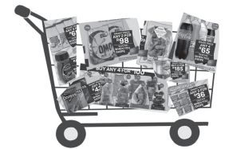  Listening for focus sounds  1. Explain to learners that you are going to describe different jobs people do, and guess the name of the job the person does. You will tell them the focus sound to help them. “Mr Ibrahim sells things. The name of his job starts with the sound /sh/ ... (shopkeeper). I work at a school and help you with your learning. The name of my job starts with the sound /t/ … (teacher).”  2. Here are some more examples: “Someone who:  I works at a hospital and their job starts with /n/ is a …” (nurse)  I works at a hospital and their job starts with /d/ is a …” (doctor)  I puts out fires and their job starts with /f/ is a …” (fireman)  I fixes water leaks and their job starts with /p/ is a …” (plumber)  I helps sick animals and their job starts with /v/ is a …” (vet)  I serves at a restaurant and their job starts with /w/ is a …” (waiter or waitress)  I looks after our teeth and their job starts with /d/ is a …” (dentist)  I grows lots of vegetables to sell and their job starts with /f/ is a …” (farmer)  I builds houses and their job starts with /b/ is a …” (builder)
 |  |  |  | Red group | Activity 4: Fine motor skills and handwriting
 |  |  |  | Purple group | Activity 3: Independent Reading
 |  |  |  | Blue group | Activity 2: Puzzle and games
 |  |  |  | Green group | Activity 1: Draw and Emergent writing
 |  |  |  | Yellow group | Activity 5: Pretend Play
Story Every day 20min | For fun and relaxation- different from the Home language story focus for the week

EXEMPLAR LESSON PLAN
ECD/FP: Grade R
TERM 3

DAILY PLANNER
Term : | 3 | Theme: | Water
Day: | 5 | Date:

ARRIVAL AND FREE PLAY |  | Free play outside
MORNING RING  THEME DISCUSSION  (15MIN) |  | Greeting, Register, Devotion, Weather Chart, Birthdays, News.
TEACHERS GUIDED ACTIVITY - LIFE SKILLS CAPS p.19
How can we save water? Close the tap while we brush our teeth. Fix a leaking tap. Take shorter showers.

Free Play inside
MATHEMATICS  (50 MIN) | Mental Maths/ Oral Counting:  Focus Activity  Day 5: Whole class Teacher Guided activities.(15-25min |  | TEACHERS GUIDED ACTIVITY - MATHEMATICS CAPS p. 176 - 180  1. Song: Sing the song, Looby loo.  2. Oral counting: 1–20 and 10–1.  - Counting objects 1–10: Five learners stand around the six hula hoops. Play music. When the music stops, learners place the number of body parts you say over the hoop. For example: ‘Show me five heads, ten elbows, four feet, nine fingers.’  - Position and direction: Place a loose elastic/wool band on each learner’s right hand.  - Symmetry: Show learners the A4 piece of paper.
MATHEMATICS  (50 MIN) | Teacher Guided Activity:  Focus group  Purple group: |  | 1. Counting objects 1–10: Learners count out 10 attribute blocks from their tubs.  - Practising shapes: Learners sort their attribute blocks according to their similarities and differences. They place them in the correct column on their shape sorting page.  - Dot cards (1–7): Give each learner a dot card. They take turns to use their fruit counters and copy the dot arrangements on their cards. Check each learner’s arrangement before giving them new cards.  Check that learners are able to:  . Count 10 objects  . Identify and copy arrangement of objects (1-7) to dot cards  . Apply a line of symmetry in shapes  . Recognize and name rectangles and describe their properties  Assessment
MATHEMATICS  (50 MIN) | Blue group |  | Workstation 1: Learners complete the shape in the picture so that both sides are the same, which makes the shape symmetrical. They colour the two sides using two different colours.
MATHEMATICS  (50 MIN) | Green group |  | Workstation 2: Learners copy or trace the individual shapes and draw a picture using all the shapes
MATHEMATICS  (50 MIN) | Yellow group |  | Workstation 3: Learners paste rectangle shapes onto paper to make a rectangle person.
MATHEMATICS  (50 MIN) | Red group |  | Workstation 4: Learners build puzzles.
FOCUS: LIFE SKIILLS CREATIVE ART/ PERCEPTUAL/ SCIENCE  (15min) | Focus Activity:  Blue group |  | Create in 2D: Draw and paint freely using the week’s topic. Working in different formats and paper sizes and brushes of different sizes to work with increased detail . Learners make an ocean aquarium: Use paper plate paint half of the plate blue and put sand on the other half colour, cut and paste the fishes and seaweed.  Science: Ask learners what will happen when we mix sugar with water? Let each learner throw a little bit of sugar in the water. Mix rice with water it will also dissolve, explore with different objects? Explore things that sink or float  Encourage development of skills through manipulation of the materials  Learners make their own boat using egg trays, straws and cardboard, or any  other waist material that can be used.  Learners can make their own octopus using a paper plate and strings of papers  DBE Workbook  Assessment
 | Green group |  | Side Activity 1:Educational toys
 | Yellow group |  | Side Activity 2:Strings and beads
 | Red group |  | Side Activity 3: Cutting activity: Playdough
 | Purple group |  | Side Activity 4: Fantasy corner
PHYSICAL EDUCATION:  (42min) | 1 x Focus activity  4 x Wellness2life Programme & 4 Independent Workstations  TEACHER GUIDED ACTIVITY – PHYSICAL EDUCATION: CAPS: p. 28  Locomotor: Non-locomotor: bending, stretching and curling the body into various shapes  Perceptual motor: Jump over low obstacles such as low held rope  Balance: Identify different ways of moving across balancing beams, jump off and soft landing (bend the knees)  Spatial orientation: Jump over and move under obstacles, crawling, climbing, jumping, etc.
TEACHERS GUIDED ACTIVITY–HOME LANGUAGE CAPS 43 – 47 (Language Activity Guide Term 2 Grade R Language Improvement Program. 36 – 42) 30min)
LANGUAGE RING  LISTENING AND SPEAKING  EMERGENT READING  EMERGENT WRITING  Small Group Activities ( Refer to Activity Guide Term 3 page 41- 42 for steps) |  | SONG: Sam and Zinzi went shopping, went shopping, went shopping;  Sam and Zinzi went shopping to buy their Mama’s food.  Spot, the doggie, went with them, went with them, went with them;  Spot, the doggie, went with them to see what he could find.  When they got back home again, home again, home again;  When they got back home again, Mommy said: “Where is Spot?”  Musa kindly brought Spot back, brought Spot back, brought Spot back;  Musa kindly brought Spot back, they all said: “Thank you, Musa!” |  | Phonic:  High frequency words: |  | Phonic sound: “o”  High frequent word: “what”
 |  |  |  | Vocabulary for the story: |  | Jam, eggs, butter, bread, milk, crumbs
 |  |  |  | Story: |  | Title: Spot goes to the shop
 |  |  |  | Whole Class:  (Story Base)  Whole Class:  (Letter & Sound) |  | Make, draw and write  1. Say to the learners: “Do you think Spot stayed safely at home after he was brought home? No! Spot loves walking the streets, doesn’t he? In fact, Spot went on another adventure the very next day! Where do you think Spot went?  What happened to him?”  2. Explain to the learners that you are going to write another story about Spot going on an adventure. Say to them: “Let’s write our own story. Let’s think together. Does the story begin in the day or the night? Where is Spot? Who is he with?” Once learners have shared ideas about the beginning of the story, discuss and agree on what they want to say. Write down their words. You can begin with the words: “Once upon a time” or “One day”.  3. Say to the learners: “Now that we have written the beginning of our story, who has ideas of what could happen next?” Listen to a few ideas, and then negotiate with the learners about the events in the story. Write down the learners’ words, then go back and read the story from the beginning.  4. Then say: “Now we need to think how the story ended. What next happened to  Spot? Who has ideas about what to write for the end of the story?” Write down the learners’ words, and then finish with the words “The End”. Read the story from the beginning, pointing to each word as you read.  5. If there is time, you can ask some of the learners to illustrate the story. Stick the story on the wall.  Blending and segmenting (syllables)  1. Explain to learners that Spot (the sock puppet) is going to look in the bag with multisyllabic objects or pictures and say a word in a broken-up way (for example: mon | ey). You must then try and guess what Spot is saying.  2. Once you have done this with a few words, ask if any of the learners would like to wear the sock puppet and look in the bag. They can pretend to be Spot and say the word in a broken-up way. The other learners must guess what they are saying.
 |  |  |  | Purple group | Activity 5: Pretend Play
 |  |  |  | Blue group | Activity 4: Fine motor skills and handwriting
 |  |  |  | Green group | Activity 3: Independent Reading
 |  |  |  | Yellow group | Activity 2: Puzzle and games
 |  |  |  | Red group | Activity 1: Draw and Emergent writing
Story Every day 20min |  | For fun and relaxation- different from the Home language story focus for the week

