
EXEMPLAR LESSON PLAN
ECD/FP: Grade R
TERM 3

DAILY PLANNER

Term : | 3 | Theme: | Jobs People do
Day: | 1 | Date:

ARRIVAL AND FREE PLAY | Free play outside
MORNING RING  THEME DISCUSSION  (15MIN) | Greeting, Register, Devotion, Weather Chart, Birthdays, News.
MORNING RING  THEME DISCUSSION  (15MIN) | TEACHERS GUIDED ACTIVITY - LIFE SKILLS CAPS p.19  Discuss items on the theme table. Farmer, doctor, fireman, policeman, different jobs. Discuss the different people who help us. First start with the people who take care of us at home. What work do the caregivers do? Why do they need to work?  Discuss, using backdrop and related material on the theme table. (fireman, librarian, policeman, nurse, doctor, teacher dentist, postman, garbage collector) Who else helps you? The Fireman: He works at the Fire Station. Discuss protective clothing. Why such big boots and gloves? Discuss equipment on display. The Policeman works at the police station. No need to fear a policeman. He is our friend and law keeper. He protects and serves. Discuss procedures in an emergency. Importance of knowing our name, address and phone numbers.
Free Play inside
MATHEMATICS  (50 MIN) |  | Mental Maths/ Oral Counting:  Focus Activity  Day 1:  Whole class Teacher Guided activities.  (15-25min) | TEACHERS GUIDED ACTIVITY - MATHEMATICS CAPS p. 172 – 175  - Song: Sing the song, Seven green speckled frogs.  - Oral counting: 1–20 and 10–1.    - Counting objects 1–10: Hold up one finger at a time and together count 1–10. Learners turn to a partner and take turns to count one another’s fingers. 4 Introducing number 7: Point to number friezes 1–6.  seven  7
 |  | Teacher Guided Activity:  (25-30min)  Focus group  Blue group | 1.Word problems: Look at the seven frogs and seven playdough flies.  2. Practising more than, fewer than, equal to: Look at the seven frogs and seven flies again.  3.Add, take away: Learners use counters to represent the frogs. Ask Learners use the counters in their tubs to represent and solve problems  4.Counting objects 1–10 and 10–1: Learners make and count 10 flies each. They count backwards from 10 to 1.  5.Practising numbers 1–7: Learners take out a number symbol card. They build a tower with the Unifix blocks to match this. They match their dot cards and number word cards to their number symbol and tower.  6.Shake and break: Learners use seven counters to shake and break. Discuss how the learners have broken up 7.  Compare groups by asking learners to put three counters on one lid and four on the other.  7.Dice: Roll the dice. Learners quickly say the number of dots on the dice.  8.Practising number 7 using playdough: The learners make the number symbol 7 out of playdough. Support learners who are ready to write 7.  Check that learners are able to:  . count objects 1-10  . count backwards 10-1,  . identify more, fewer and equal  . recognise, match, name and order number symbols, number words and dot cards 1-7  . match objects with dot cards 1-7  .solve addition and subtraction problems to 7  .identify dots 1-6 on a dice Assessment
 |  | Green group | Workstation 1: Learners use playdough to complete the template.
 |  | Yellow group | Workstation 2: Learners ‘fill’ the jars with the correct number of sweets to correspond with the number on each jar
 |  | Red group | Workstation 3: Learners take turns to roll the dice and then put the same number of objects into their cups as the number the dice lands on.
 |  | Purple group | Workstation 4: Learners each choose a number puzzle. They find the matching number and picture pieces.
FOCUS: LIFE SKIILLS CREATIVE ART/ PERCEPTUAL/ SCIENCE  (15min) |  | Focus Activity  Green group | Create in 2D: Draw and paint freely using the week’s topic. Working in different formats and paper sizes. Use the 2 doctor’s templets: Colour and cut the doctor’s suite case. Fold in halve and paste all the doctor’s equipment inside the doctor’s case. Let learners finger paint the house that is on fire. Learners make their own bakers chef hat – use templet and décor the hat. ( Keep hat for Fridays baking and making). Learners make a post box with a toilet roll.  News Book DBE Workbook Assessment
 |  | Yellow group | Side Activity 1: Playdough – Make a firefighter
 |  | Red group | Side Activity 2: Educational toys
 |  | Purple group | Side Activity 3: Cutting activity: Playdough
 |  | Blue group | Side Activity 4: Thread a pattern
PHYSICAL EDUCATION:  (42min) |  |   1 x Focus activity  4 x Wellness2life Programme & 4 Independent Workstations  TEACHER GUIDED ACTIVITY – PHYSICAL EDUCATION: CAPS: p. 28 Rhythm  Simple hopscotch, single take-off to single landing; single take-off to double feet landing; double take-off to single foot landing  Co-ordination Jungle gym - arm travelling while hanging with over-grasp  Balance: Identify different ways of moving across balancing beams, jump off and soft landing (bend the knees)  Spatial orientation Speed: walking fast, march faster, running faster along a straight line, curved line and zigzag  Laterality Hopping on non-dominant foot
TEACHERS GUIDED ACTIVITY–HOME LANGUAGE CAPS 43 – 47 (Language Activity Guide Term 2 Grade R Language Improvement Program. 29 – 35) 30min)
LANGUAGE RING  LISTENING AND SPEAKING  EMERGENT READING  EMERGENT WRITING  Small Group Activities ( Refer to Activity Guide Term 3 page 34- 35 for steps) | SONG: Sam and Zinzi went shopping, went shopping, went shopping;  Sam and Zinzi went shopping to buy their Mama’s food.  Spot, the doggie, went with them, went with them, went with them;  Spot, the doggie, went with them to see what he could find.  When they got back home again, home again, home again;  When they got back home again, Mommy said: “Where is Spot?”  Musa kindly brought Spot back, brought Spot back, brought Spot back;  Musa kindly brought Spot back, they all said: “Thank you, Musa!” |  |  | Phonic:  High frequency words: |  | Phonic sound: “m”  High frequent word: “are”
 |  |  |  | Vocabulary |  | Jam, eggs, butter, bread, milk, crumbs
 |  |  |  | Story: |  | Title: Spot goes to the shop
 |  |  |  | Whole Class:  (Story Base)  Whole Class:  (Letter & Sound) |  | 1. Before you tell the story  1.1. Tell learners the title of the story and introduce the characters using the puppets.  1.2. Relate the story to learners’ lives by asking: “Who has got a dog at home? What is your dog’s name? Has your dog ever got lost before?”  1.3. Say: “Before we begin, I want to tell you the meaning of some new words which we will find in the story.” Discuss the keywords from the vocabulary list, and show learners an object or a picture to show them what a word means. For example: Show them how a slice of bread can be broken into crumbs.  2. While you tell the story  2.1. Tell the story in a lively way and use different voices. Do actions and make use of the puppets and props.  2.2. Ask learners to predict what happens next in the story and involve them through open-ended questions, such as: “What do you think Mrs Madiswa is going to say when the children get home without Spot? Why didn’t Spot notice when the children left? If Musa hadn’t brought Spot home, what would Zinzi and Sam have done?”  3. After you tell the story  3.1. Ask learners: “What did you like about the story? What didn’t you like? What was your best part? What questions do you have about the story?”  Introducing a sound from the story  1. Ask learners to sit on the mat and listen carefully to you. Say these words from the story: “money, milk, mother, Ma Madiswa, Mr. Can you hear the focus sound: money, milk, mother, Ma Madiswa, Mr? Yes, you are right! They all have the sound /m/.”  2. “Listen carefully, here are some more words with /m/: monkey, man, meat, moon, mushroom, moth, music, mouse.” (Emphasise the focus sound as you say these words.)  3. Say the sound /m/ clearly and tell learners to watch your mouth.  4. Ask learners to say the sound /m/: “m-m-m”. Make this fun: Say it softly, loudly, to the wall, to the ceiling and to each other. Make sure learners are saying the sound of the letter and not the letter name, m (“em”).
 |  |  |  | Blue group | Activity 1: Draw and Emergent writing. Assessment
 |  |  |  | Green group | Activity 5: Pretend Play
 |  |  |  | Yellow group | Activity 4: Fine motor skills and handwriting
 |  |  |  | Red group | Activity 3: Independent Reading
 |  |  |  | Purple group | Activity 2: Puzzle and games
Story Every day 20min | For fun and relaxation- different from the Home language story focus for the week

EXEMPLAR LESSON PLAN ECD/FP: Grade R
TERM 3

DAILY PLANNER
Term : | 3 | Theme: | Jobs People do
Day: | 2 | Date:

ARRIVAL AND FREE PLAY | Free play outside
MORNING RING  THEME DISCUSSION  (15MIN) | Greeting, Register, Devotion, Weather Chart, Birthdays, News.
MORNING RING  THEME DISCUSSION  (15MIN) | TEACHERS GUIDED ACTIVITY - LIFE SKILLS CAPS p.19  Jobs relating to health: doctor, dentist, paramedic. Occupations in the Medical Profession. A visit by a Dentist/Doctor/ Nurse/Vet from the local community hospital or one of the professional parents. Alternatively discuss how the above people help us. Refer to theme table.
Free Play inside
MATHEMATICS  (50 MIN) |  | Mental Maths/ Oral Counting:  Focus Activity  Day 2: Whole class Teacher Guided activities.  (15-25min) | MATHEMATICS CAPS p. 172 - 175  - Song: Sing the song, Seven green speckled frogs and dramatize it.  - Oral counting: 1–20 and 10–1.  - Counting objects 1–10: Sing, One little, two little, while showing fingers 1–10.  - Dot cards 1–7 game: Play the ‘grouping game’ from Week 2 (page 23: Activity 4, Day 3) to get learners into groups of seven. Use dot, picture and number symbol cards 1–7.  Maths table: Groups of seven learners collect seven similar small objects inside or outside the classroom, for example, blocks, kokis, stones or waste materials. Learners return to sit on the mat in their groups. Each group says what, and how many, they have found. Discuss the similarities and differences between collections. Give a number 7 dot, symbol and word card to each group. One group at a time puts their objects and number 7 cards on the table
 |  | Teacher Guided Activity:  Focus group  (25-30min)  Green group | 1.Word problems: Look at the seven frogs and seven playdough flies.  2. Practising more than, fewer than, equal to: Look at the seven frogs and seven flies again.  3.Add, take away: Learners use counters to represent the frogs. Ask Learners use the counters in their tubs to represent and solve problems  4.Counting objects 1–10 and 10–1: Learners make and count 10 flies each. They count backwards from 10 to 1.  5.Practising numbers 1–7: Learners take out a number symbol card. They build a tower with the Unifix blocks to match this. They match their dot cards and number word cards to their number symbol and tower.  6.Shake and break: Learners use seven counters to shake and break. Discuss how the learners have broken up 7.  Compare groups by asking learners to put three counters on one lid and four on the other.  7.Dice: Roll the dice. Learners quickly say the number of dots on the dice.  8.Practising number 7 using playdough: The learners make the number symbol 7 out of playdough. Support learners who are ready to write 7.
  Check that learners are able to:
  - count objects 1–10
  - count backwards 10–1
  - identify more, fewer and equal
  - recognise, match, name and order number symbols, number words and dot cards 1–7
  - match objects with dot cards 1–7
  - solve addition and subtraction problems to 7
  - identify dots 1–6 on a dice
 |  | Yellow group | Workstation 1: Learners use playdough to complete the template.
 |  | Red group | Workstation 2: Learners ‘fill’ the jars with the correct number of sweets to correspond with the number on each jar
 |  | Purple group | Workstation 3: Learners take turns to roll the dice and then put the same number of objects into their cups as the number the dice lands on.
 |  | Blue group | Workstation 4: Learners each choose a number puzzle. They find the matching number and picture pieces.
FOCUS: LIFE SKIILLS CREATIVE ART/ PERCEPTUAL/ SCIENCE  (15min) |  | Focus Activity:  Yellow group | Create in 2D: Draw and paint freely using the week’s topic. Working in different formats and paper sizes. Use the 2 doctor’s templets: Colour and cut the doctor’s suite case. Fold in halve and paste all the doctor’s equipment inside the doctor’s case. Let learners finger paint the house that is on fire. Learners make their own bakers chef hat – use templet and décor the hat. ( Keep hat for Fridays baking and making). Learners make a post box with a toilet roll.  News Book DBE Workbook Assessment
 |  | Red group | Side Activity 1: Playdough – Make a firefighter
 |  | Purple group | Side Activity 2: Educational toys
 |  | Blue group | Side Activity 3: Cutting activity: Playdough
 |  | Green group | Side Activity 4: Thread a pattern
PHYSICAL EDUCATION:  (42min) |  | 1 x Focus activity  4 x Wellness2life Programme & 4 Independent Workstations  TEACHER GUIDED ACTIVITY – PHYSICAL EDUCATION: CAPS: p. 28 Rhythm  Simple hopscotch, single take-off to single landing; single take-off to double feet landing; double take-off to single foot landing  Co-ordination Jungle gym - arm travelling while hanging with over-grasp  Balance: Identify different ways of moving across balancing beams, jump off and soft landing (bend the knees)  Spatial orientation Speed: walking fast, march faster, running faster along a straight line, curved line and zigzag  Laterality Hopping on non-dominant foot
TEACHERS GUIDED ACTIVITY–HOME LANGUAGE CAPS 43 – 47 (Language Activity Guide Term 2 Grade R Language Improvement Program. 29 – 35) 30min)
LANGUAGE RING  LISTENING AND SPEAKING  EMERGENT READING  EMERGENT WRITING  Small Group Activities ( Refer to Activity Guide Term 3 page 34- 35 for steps) | SONG: Sam and Zinzi went shopping, went shopping, went shopping;  Sam and Zinzi went shopping to buy their Mama’s food.  Spot, the doggie, went with them, went with them, went with them;  Spot, the doggie, went with them to see what he could find.  When they got back home again, home again, home again;  When they got back home again, Mommy said: “Where is Spot?”  Musa kindly brought Spot back, brought Spot back, brought Spot back;  Musa kindly brought Spot back, they all said: “Thank you, Musa!” |  |  | Phonic:  High frequency words: |  | Phonic sound: “m”  High frequent word: “are”
 |  |  |  | Vocabulary for the story: |  | Jam, eggs, butter, bread, milk, crumbs
 |  |  |  | Story: |  | Title: Spot goes to the shop
 |  |  |  | Whole Class:  (Story Base)  Whole Class:  (Letter & Sound)   |  | Storytelling and singing  1. Begin by reminding learners of the meaning of words that you introduced on Day 1.  2. Retell the story using the puppets. Ask questions as you tell the story. Encourage learners to predict what will happen next.  3. Tell learners you are going to teach them a new song to go with the story.  4. Say a few lines of the song clearly and slowly, and then ask learners to join in and sing together with you. It may be difficult for learners to remember all the words, so teach the song in parts.  5. Have pictures or props or do actions to help learners understand the language of the song.  6. Teach learners the actions for the song and have fun singing in more than one language.  Forming the letter  1. Remind learners of the focus sound. Ask learners if anyone’s name starts with /m/ or if they can think of any other words that start with the sound /m/.  2. Teach learners an action associated with the sound. For example: Learners can rub their tummies while saying “m-m-m-m-m”.  3. Show learners how to write the letter m. Praise their attempts, then write a large letter on the board or in the air while saying the following: “Start at the dot, go down, up, over, down, up, over and down again.”  4. Let learners practise the letter formation in the air, on the carpet, on each other’s backs or on their hands. They can also try using their own bodies to make the letter.  5. Once you have modelled how to write the letter, go outside and encourage learners to use a stick to write the letter in the sand and walk on it.  6. Encourage learners to say the sound the letter makes as they write the letter.
 |  |  |  | Green group | Activity 2: Puzzle and games
 |  |  |  | Yellow group | Activity 1: Draw and Emergent writing. Assessment
 |  |  |  | Red group | Activity 5: Pretend Play
 |  |  |  | Purple group | Activity 4: Fine motor skills and handwriting
 |  |  |  | Blue group | Activity 3: Independent Reading
Story Every day 20min | For fun and relaxation- different from the Home language story focus for the week

EXEMPLAR LESSON PLAN
ECD/FP: Grade R
TERM 3
DAILY PLANNER

Term : | 3 | Theme: | Jobs People do
Day: | 3 | Date:

ARRIVAL AND FREE PLAY | Free play outside
MORNING RING | Greeting, Register, Devotion, Weather Chart, Birthdays, News.
THEME DISCUSSION  (15MIN) | TEACHERS GUIDED ACTIVITY - LIFE SKILLS CAPS p.19  Jobs relating to services: builder, plumber, electrician, painter.
Free Play inside
MATHEMATICS  (50 MIN) |  | Mental Maths/ Oral Counting:  Focus Activity  Day3: Whole class Teacher Guided activities.  (15-25min) | TEACHERS GUIDED ACTIVITY - MATHEMATICS CAPS p. 172 - 175  - Song: Sing the song, Seven green speckled frogs. Use the pictures as you sing the song.  - Oral counting: 1–20 and 10–1.  - Counting objects 1–10: Repeat the activity from Day 2.  - Dot cards and ordering 1–7: Slowly show learners the dot cards 1–7. They clap when they see the card with seven dots. Show learners combinations of dot cards that make seven. Start with the dot cards for 3 and 4.
 |  | Teacher Guided Activity:  Focus group  (25-30min)  Yellow group | 1.Word problems: Look at the seven frogs and seven playdough flies.  2. Practising more than, fewer than, equal to: Look at the seven frogs and seven flies again.  3.Add, take away: Learners use counters to represent the frogs. Ask Learners use the counters in their tubs to represent and solve problems  4.Counting objects 1–10 and 10–1: Learners make and count 10 flies each. They count backwards from 10 to 1.  5.Practising numbers 1–7: Learners take out a number symbol card. They build a tower with the Unifix blocks to match this. They match their dot cards and number word cards to their number symbol and tower.  6.Shake and break: Learners use seven counters to shake and break. Discuss how the learners have broken up 7.  Compare groups by asking learners to put three counters on one lid and four on the other.  7.Dice: Roll the dice. Learners quickly say the number of dots on the dice.  8.Practising number 7 using playdough: The learners make the number symbol 7 out of playdough. Support learners who are ready to write 7.  Check that learners are able to:  . count objects 1-10  . count backwards 10-1,  . identify more, fewer and equal  . recognise, match, name and order number symbols, number words and dot cards 1-7  . match objects with dot cards 1-7  .solve addition and subtraction problems to 7  .identify dots 1-6 on a dice  Assessment
 |  | Red group | Workstation 1: Learners use playdough to complete the template.
 |  | Purple group | Workstation 2: Learners ‘fill’ the jars with the correct number of sweets to correspond with the number on each jar
 |  | Blue group | Workstation 3: Learners take turns to roll the dice and then put the same number of objects into their cups as the number the dice lands on.
 |  | Green group | Workstation 4: Learners each choose a number puzzle. They find the matching number and picture pieces.
FOCUS: LIFE SKIILLS CREATIVE ART/ PERCEPTUAL/ SCIENCE  (15min) |  | Focus Activity:  Red group | Create in 2D: Draw and paint freely using the week’s topic. Working in different formats and paper sizes. Use the 2 doctor’s templets: Colour and cut the doctor’s suite case. Fold in halve and paste all the doctor’s equipment inside the doctor’s case. Let learners finger paint the house that is on fire. Learners make their own bakers chef hat – use templet and décor the hat. ( Keep hat for Fridays baking and making). Learners make a post box with a toilet roll.  News Book DBE Workbook Assessment
 |  | Purple group | Side Activity 1: Playdough – Make a firefighter
 |  | Blue group | Side Activity 2: Educational toys
 |  | Green group | Side Activity 3: Cutting activity: Playdough
 |  | Yellow group | Side Activity 4: Thread a pattern
PHYSICAL EDUCATION:  (42min) |  | 1 x Focus activity  4 x Wellness2life Programme & 4 Independent Workstations  TEACHER GUIDED ACTIVITY – PHYSICAL EDUCATION: CAPS: p. 28 Rhythm  Simple hopscotch, single take-off to single landing; single take-off to double feet landing; double take-off to single foot landing  Co-ordination Jungle gym - arm travelling while hanging with over-grasp  Balance: Identify different ways of moving across balancing beams, jump off and soft landing (bend the knees)  Spatial orientation Speed: walking fast, march faster, running faster along a straight line, curved line and zigzag  Laterality Hopping on non-dominant foot
TEACHERS GUIDED ACTIVITY–HOME LANGUAGE CAPS 43 – 47 (Language Activity Guide Term 2 Grade R Language Improvement Program. 29 – 35) 30min)
LANGUAGE RING  LISTENING AND SPEAKING  EMERGENT READING  EMERGENT WRITING  Small Group Activities ( Refer to Activity Guide Term 3 page 34- 35 for steps) | SONG: Sam and Zinzi went shopping, went shopping, went shopping;  Sam and Zinzi went shopping to buy their Mama’s food.  Spot, the doggie, went with them, went with them, went with them;  Spot, the doggie, went with them to see what he could find.  When they got back home again, home again, home again;  When they got back home again, Mommy said: “Where is Spot?”  Musa kindly brought Spot back, brought Spot back, brought Spot back;  Musa kindly brought Spot back, they all said: “Thank you, Musa!” |  |  | Phonic:  High frequency words: |  | Phonic sound: “m”  High frequent word: “are”
 |  |  |  | Vocabulary for the story: |  | Jam, eggs, butter, bread, milk, crumbs
 |  |  |  | Story: |  | Title: Spot goes to the shop
 |  |  |  | Whole Class:  (Story Base)  Whole Class:  (Letter & Sound) |  | Storytelling and role play  1. Sing the song.  2. Ask learners if they can remember the meaning of words from the vocabulary list.  For example: Ask them to act out these action words: “hug” and “follow”.  3. Choose learners to play the characters in the story.  4. Talk about each character in the story. Tell learners who they are going to be in the role play and show them the props that will be used to tell the story.  5. Explain to learners that you (the teacher) are going to be the storyteller, also known as the narrator. The acting learners are going to act out everything you say. Help them to organise where they are going to stand.  6. Start telling the story and encourage learners to do the actions to match your words while the rest of the class watches the role play.  7. If there is time, you may want to repeat the role play with different learners.  Letter boxes  1. Ask learners to sit on the mat and show them the objects and pictures in the letter box one at a time. Ask them for the names of the objects. If there are learners who speak different languages, ask them to tell the class what they call the object in their home language. Then give the word in the language of instruction. Let them hold the objects or pictures and pass them around.  2. Ask questions about the objects: “Have you seen one of these? What do we use this for? What colour is it? How does it feel?”  3. Say the names of the objects while emphasising the focus sound. Ask learners if they can hear the focus sound.  4. Ask learners to say the name of each object and emphasise the focus sound when they say the words.  5. Once learners have practised the new sound, show them the letter on the letter box. Let some learners trace over the letter on the lid with their fingers.  6. Now, combine objects from two or more letter boxes and spread them on the floor or table.  7. Ask learners to find objects that have one of the focus sounds. For example: “Can you find something that starts with the sound /m/?” The learner must name the object, say the focus sound and place the object in the correct letter box.
 |  |  |  | Yellow group | Activity 3: Independent Reading
 |  |  |  | Red group | Activity 2: Puzzle and games
 |  |  |  | Purple group | Activity 1: Draw and Emergent writing. Assessment
 |  |  |  | Blue group | Activity 5: Pretend Play
 |  |  |  | Green group | Activity 4: Fine motor skills and handwriting
Story Every day 20min | For fun and relaxation- different from the Home language story focus for the week

EXEMPLAR LESSON PLAN
ECD/FP: Grade R
TERM 3

DAILY PLANNER

Term : | 3 | Theme: | Jobs People do
Day: | 4 | Date:

ARRIVAL AND FREE PLAY | Free play outside
MORNING RING  THEME DISCUSSION  (15MIN | Greeting, Register, Devotion, Weather Chart, Birthdays, News.
MORNING RING  THEME DISCUSSION  (15MIN | TEACHERS GUIDED ACTIVITY - LIFE SKILLS CAPS p.19  Jobs relating to food: shop keepers, waiters, baker, and farmer. The Baker works at a bakery. Refer to the objects, pictures on the theme table ears of wheat, bread, cakes, biscuits, sugar, eggs milk etc.
Free Play inside
MATHEMATICS  (50 MIN) |  | Mental Maths/ Oral Counting:  Focus Activity  Day4: Whole class Teacher Guided activities.  (15-25min) | TEACHERS GUIDED ACTIVITY - MATHEMATICS CAPS p. 172 - 175  - Song: Sing the song, Seven green speckled frogs together and then look at number friezes 1–7.  - Oral counting: 1–20 and 10–1.  - Counting objects 1–10: Learners count the fingers on a pair of gloves.  - Practising and ordering 1–7: Create a ‘Number 7’ dance, for example, stamp seven times, nod seven times and sway seven times.
 |  | Teacher Guided Activity:  Focus group  Red group | 1.Word problems: Look at the seven frogs and seven playdough flies.  2. Practising more than, fewer than, equal to: Look at the seven frogs and seven flies again.  3.Add, take away: Learners use counters to represent the frogs. Ask Learners use the counters in their tubs to represent and solve problems  4.Counting objects 1–10 and 10–1: Learners make and count 10 flies each. They count backwards from 10 to 1.  5.Practising numbers 1–7: Learners take out a number symbol card. They build a tower with the Unifix blocks to match this. They match their dot cards and number word cards to their number symbol and tower.  6.Shake and break: Learners use seven counters to shake and break. Discuss how the learners have broken up 7.  Compare groups by asking learners to put three counters on one lid and four on the other.  7.Dice: Roll the dice. Learners quickly say the number of dots on the dice.  8.Practising number 7 using playdough: The learners make the number symbol 7 out of playdough. Support learners who are ready to write 7.  Check that learners are able to:  . count objects 1-10  . count backwards 10-1,  . identify more, fewer and equal  . recognise, match, name and order number symbols, number words and dot cards 1-7  . match objects with dot cards 1-7  .solve addition and subtraction problems to 7  .identify dots 1-6 on a dice  Assessment
 |  | Purple group | Workstation 1: Learners use playdough to complete the template.
 |  | Blue group | Workstation 2: Learners ‘fill’ the jars with the correct number of sweets to correspond with the number on each jar
 |  | Green group | Workstation 3: Learners take turns to roll the dice and then put the same number of objects into their cups as the number the dice lands on.
 |  | Yellow group | Workstation 4: Learners each choose a number puzzle. They find the matching number and picture pieces.
FOCUS: LIFE SKIILLS CREATIVE ART/ PERCEPTUAL/ SCIENCE  (15min) |  | Focus Activity: Purple group | Create in 2D: Draw and paint freely using the week’s topic. Working in different formats and paper sizes. Use the 2 doctor’s templets: Colour and cut the doctor’s suite case. Fold in halve and paste all the doctor’s equipment inside the doctor’s case. Let learners finger paint the house that is on fire. Learners make their own bakers chef hat – use templet and décor the hat. ( Keep hat for Fridays baking and making). Learners make a post box with a toilet roll.  News Book DBE Workbook Assessment
 |  | Blue group | Side Activity 1: Playdough – Make a firefighter
 |  | Red group | Side Activity 2: Educational toys
 |  | Green group | Side Activity 3: Cutting activity: Playdough
 |  | Yellow group | Side Activity 4: Thread a pattern
PHYSICAL EDUCATION:  (42min) |  | 1 x Focus activity  4 x Wellness2life Programme & 4 Independent Workstations  TEACHER GUIDED ACTIVITY – PHYSICAL EDUCATION: CAPS: p. 28 Rhythm  Simple hopscotch, single take-off to single landing; single take-off to double feet landing; double take-off to single foot landing  Co-ordination Jungle gym - arm travelling while hanging with over-grasp  Balance: Identify different ways of moving across balancing beams, jump off and soft landing (bend the knees)  Spatial orientation Speed: walking fast, march faster, running faster along a straight line, curved line and zigzag  Laterality Hopping on non-dominant foot
TEACHERS GUIDED ACTIVITY–HOME LANGUAGE CAPS 43 – 47 (Language Activity Guide Term 2 Grade R Language Improvement Program. 29 – 35) 30min)
LANGUAGE RING  LISTENING AND SPEAKING  EMERGENT READING  EMERGENT WRITING  Small Group Activities ( Refer to Activity Guide Term 3 page 34- 35 for steps) | SONG: Sam and Zinzi went shopping, went shopping, went shopping;  Sam and Zinzi went shopping to buy their Mama’s food.  Spot, the doggie, went with them, went with them, went with them;  Spot, the doggie, went with them to see what he could find.  When they got back home again, home again, home again;  When they got back home again, Mommy said: “Where is Spot?”  Musa kindly brought Spot back, brought Spot back, brought Spot back;  Musa kindly brought Spot back, they all said: “Thank you, Musa!” |  |  | Phonic:  High frequency words: |  | Phonic sound: “m”  High frequent word: “are”
 |  |  |  | Vocabulary for the story: |  | Jam, eggs, butter, bread, milk, crumbs
 |  |  |  | Story: |  | Title: Spot goes to the shop
 |  |  |  | Whole Class:  (Story Base)  Whole Class:  (Letter & Sound) |  | Sequencing pictures  1. Sing the song again.  2. Introduce new words from the vocabulary list.  3. Choose one of the sequence pictures and hold it up. Ask learners what they see, then talk about the picture in detail.  4. Once you have discussed each picture, stick it on the board so learners can see it.  Make sure the pictures are not in sequence at this stage of the activity.  5. After talking about all the pictures, ask learners: “Are the pictures in the correct order?”  6. Ask learners to point out the picture for the beginning of the story. Work together to arrange the sequence of the pictures so the story makes sense.  7. Keep learners actively involved in this process. Ask questions like: “What happened next? Who can remember the next part of the story?”  8. When the pictures are in the correct order, invite a few learners to retell the story in the correct sequence.  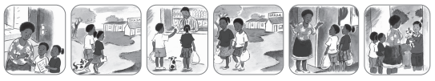  Listening for focus sounds  1. Explain to learners that you are going to describe different jobs people do, and they must try and guess the name of the job the person does. You will tell them the focus sound to help them. “Mr Ibrahim sells things. The name of his job starts with the sound /sh/ ... (shopkeeper). I work at a school and help you with your learning. The name of my job starts with the sound /t/ … (teacher).”  2. Here are some more examples: “Someone who:  I works at a hospital and their job starts with /n/ is a …” (nurse)  I works at a hospital and their job starts with /d/ is a …” (doctor)  I puts out fires and their job starts with /f/ is a …” (fireman)  Ì fixes water leaks and their job starts with /p/ is a …” (plumber)  I helps sick animals and their job starts with /v/ is a …” (vet)  I serves at a restaurant and their job starts with /w/ is a …” (waiter or waitress)  I looks after our teeth and their job starts with /d/ is a …” (dentist)  I grows lots of vegetables to sell and their job starts with /f/ is a …” (farmer)  I builds houses and their job starts with /b/ is a …” (builder)
 |  |  |  | Red group | Activity 4: Fine motor skills and handwriting
 |  |  |  | Purple group | Activity 3: Independent Reading
 |  |  |  | Blue group | Activity 2: Puzzle and games
 |  |  |  | Green group | Activity 1: Draw and Emergent writing. Assessment
 |  |  |  | Yellow group | Activity 5: Pretend Play
Story Every day 20min | For fun and relaxation- different from the Home language story focus for the week

EXEMPLAR LESSON PLAN
ECD/FP: Grade R
TERM 3
DAILY PLANNER

Term : | 3 | Theme: | Jobs People do
Day: | 5 | Date:

ARRIVAL AND FREE PLAY | Free play outside
MORNING RING  THEME DISCUSSION  (15MIN) | Greeting, Register, Devotion, Weather Chart, Birthdays, News.
MORNING RING  THEME DISCUSSION  (15MIN) | TEACHERS GUIDED ACTIVITY - LIFE SKILLS CAPS p.19  People who help us in the community: fireman, policeman, garbage collector. The Postman works at the post office. He delivers our mail to our homes; to Post office boxes; all letters need an address; air mail; surface mail; stamps; posting letters and parcels; collecting mail at the post office.
Free Play inside
MATHEMATICS  (50 MIN) |  | Mental Maths/ Oral Counting:  Focus Activity  Day 5: Whole class Teacher Guided activities.  (15-25min) | 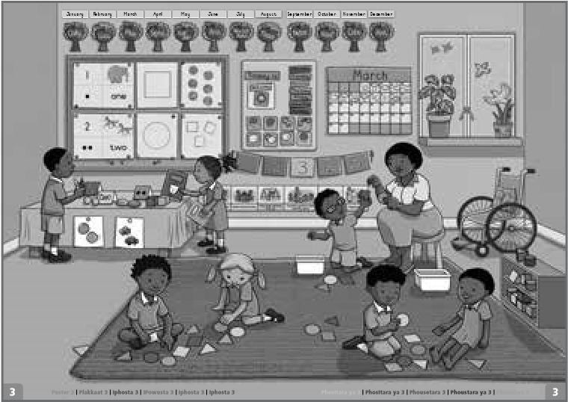  TEACHERS GUIDED ACTIVITY - MATHEMATICS CAPS p. 172 - 175  - Song: Sing the song, Seven green speckled frogs together.  - Oral counting: 1–20 and 10–1.  - Counting objects 1–10: Together count ten learners to sit in a row and  place one pair of gloves in front of each learner.  - Jumping track: Use masking tape or chalk to create a ladder on the  mat for learners to jump as the class counts 1–7.  - Practising 1–7: Discuss Poster 3. Talk about what the learners can see.
 |  | Teacher Guided Activity:  Focus group  Purple group | 1.Word problems: Look at the seven frogs and seven playdough flies.  2. Practising more than, fewer than, equal to: Look at the seven frogs and seven flies again.  3.Add, take away: Learners use counters to represent the frogs. Ask Learners use the counters in their tubs to represent and solve problems  - Counting objects 1–10 and 10–1: Learners make and count 10 flies each. They count backwards from 10 to 1.  - Practising numbers 1–7: Learners take out a number symbol card. They build a tower with the Unifix blocks to match this. They match their dot cards and number word cards to their number symbol and tower.  - Shake and break: Learners use seven counters to shake and break. Discuss how the learners have broken up 7.  - Dice: Roll the dice. Learners quickly say the number of dots on the dice.  - Practising number 7 using playdough: The learners make the number symbol 7 out of playdough. Support learners who are ready to write 7.  Check that learners are able to:  . count objects 1-10  . count backwards 10-1,  . identify more, fewer and equal  . recognise, match, name and order number symbols, number words and dot cards 1-7  . match objects with dot cards 1-7  .solve addition and subtraction problems to 7  .identify dots 1-6 on a dice  Assessment
 |  | Blue group | Workstation 1: Learners use playdough to complete the template.
 |  | Green group | Workstation 2: Learners ‘fill’ the jars with the correct number of sweets to correspond with the number on each jar
 |  | Yellow group | Workstation 3: Learners take turns to roll the dice and then put the same number of objects into their cups as the number the dice lands on.
 |  | Red group | Workstation 4: Learners each choose a number puzzle. They find the matching number and picture pieces.
FOCUS: LIFE SKIILLS CREATIVE ART/ PERCEPTUAL/ SCIENCE  (15min) |  | Focus Activity:  Blue group | Create in 2D: Draw and paint freely using the week’s topic. Working in different formats and paper sizes. Use the 2 doctor’s templets: Colour and cut the doctor’s suite case. Fold in halve and paste all the doctor’s equipment inside the doctor’s case. Let learners finger paint the house that is on fire. Learners make their own bakers chef hat – use templet and décor the hat. ( Keep hat for Fridays baking and making). Learners make a post box with a toilet roll.  News Book DBE Workbook Assessment
 |  | Green group | Side Activity 1: Playdough – Make a firefighter
 |  | Yellow group | Side Activity 2: Educational toys
 |  | Red group | Side Activity 3: Cutting activity: Playdough
 |  | Purple group | Side Activity 4: Thread a pattern
PHYSICAL EDUCATION:  (42min) |  | 1 x Focus activity  4 x Wellness2life Programme & 4 Independent Workstations  TEACHER GUIDED ACTIVITY – PHYSICAL EDUCATION: CAPS: p. 28 Rhythm  Simple hopscotch, single take-off to single landing; single take-off to double feet landing; double take-off to single foot landing  Co-ordination Jungle gym - arm travelling while hanging with over-grasp  Balance: Identify different ways of moving across balancing beams, jump off and soft landing (bend the knees)  Spatial orientation Speed: walking fast, march faster, running faster along a straight line, curved line and zigzag  Laterality Hopping on non-dominant foot
TEACHERS GUIDED ACTIVITY–HOME LANGUAGE CAPS 43 – 47 (Language Activity Guide Term 2 Grade R Language Improvement Program. 29 – 35) 30min)
LANGUAGE RING  LISTENING AND SPEAKING  EMERGENT READING  EMERGENT WRITING  Small Group Activities ( Refer to Activity Guide Term 3 page 34- 35 for steps) | SONG: Sam and Zinzi went shopping, went shopping, went shopping;  Sam and Zinzi went shopping to buy their Mama’s food.  Spot, the doggie, went with them, went with them, went with them;  Spot, the doggie, went with them to see what he could find.  When they got back home again, home again, home again;  When they got back home again, Mommy said: “Where is Spot?”  Musa kindly brought Spot back, brought Spot back, brought Spot back;  Musa kindly brought Spot back, they all said: “Thank you, Musa!” |  |  | Phonic:  High frequency words: |  | Phonic sound: “m”  High frequent word: “are”
 |  |  |  | Vocabulary for the story: |  | Jam, eggs, butter, bread, milk, crumbs
 |  |  |  | Story: |  | Title: Spot goes to the shop
 |  |  |  | Whole Class:  (Story Base)  Whole Class:  (Letter & Sound) |  | Make, draw and write  1. Write the title, “My shopping list”, at the top of each learner’s page before the lesson. Read the title together pointing to each word.  2. Talk about what we buy at different kinds of shops and let learners share their shopping experiences.  3. Tell learners you are going shopping and need them to help you make a shopping list. Ask them to give suggestions of what to buy.  4. Write down the list and draw a simple picture next to each word. Read the list together.  5. Explain to learners that they are going to make their own shopping list. (Remove your list so learners don’t copy.)  6. Learners draw items they want to buy, and “have a go” at “writing” the words using pretend writing or invented spelling.  7. Learners can “read” their shopping lists to each other.  Blending and segmenting (syllables)  1. Explain to learners that Spot (the sock puppet) is going to look in the bag with multisyllabic objects or pictures and say a word in a broken-up way (for example: mon | ey).  You must then try and guess what Spot is saying.  2. Once you have done this with a few words, ask if any of  the learners would like to wear the sock puppet and look  in the bag. They can pretend to be Spot and say the word  in a broken-up way. The other learners must guess what  they are saying
 |  |  |  | Purple group | Activity 5: Pretend Play
 |  |  |  | Blue group | Activity 4: Fine motor skills and handwriting
 |  |  |  | Green group | Activity 3: Independent Reading
 |  |  |  | Yellow group | Activity 2: Puzzle and games
 |  |  |  | Red group | Activity 1: Draw and Emergent writing. Assessment
Story Every day 20min | For fun and relaxation- different from the Home language story focus for the week

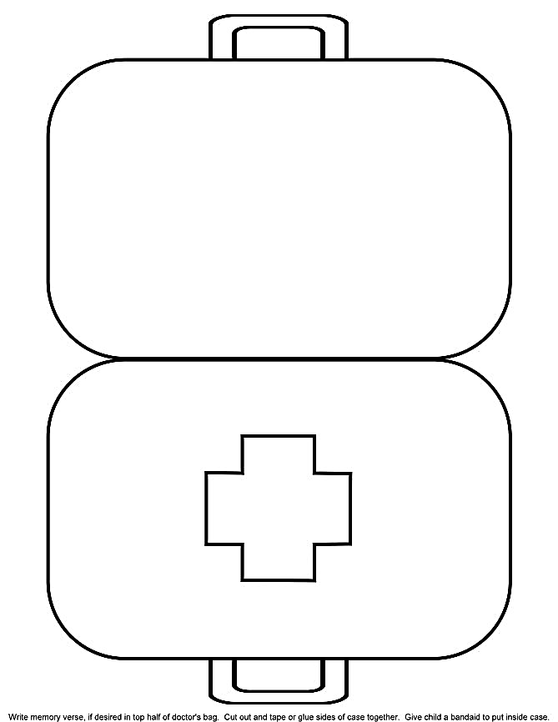

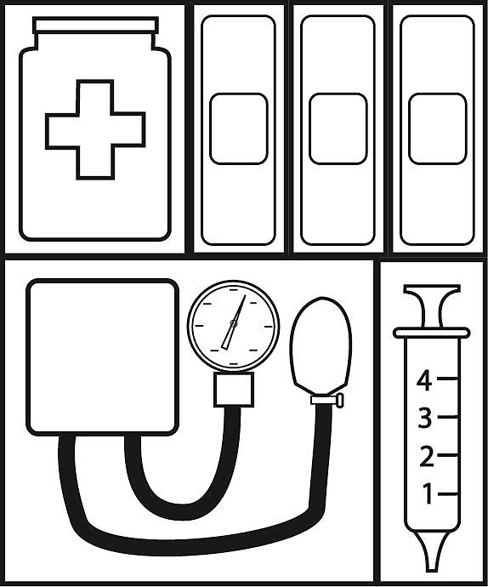

Firefighters :
House is on Fire


