JS 2026 Annual Teaching Plan – Term 2: SUBJECT: LIFE SKILLS Grade R
ANNUAL TEACHING PLAN
GRADE R LIFE SKILLS TERM 2
HEALTH CHECK
Daily hygiene routines are to be strictly followed:
- Remind learners of the daily routine when coming to school.
- Encourage learners to stay at home when ill.
- Slogan: Keep your distance - Teach learners about social distancing and how to greet without touching.
- Supervise snack and lunchtime.
- Teach them to cover their mouth and nose with a flexed elbow or tissue when coughing or sneezing. Dispose of the used tissue immediately.
- Teach them to avoid touching their Mouth, Eyes, Nose (MEN)
- Wash hands with soap and water often and sanitize your hands
- Sanitize and clean frequently touched surfaces toys, stationery, objects, etc. Introduce this practice as routine.
- If you have no sanitizer you could make a sterilising solution by mixing 5 table spoons of bleach to 1 litre of water

N.B. TEACHERS TO ENSURE THE SAFETY OF THEIR LEARNERS IN THEIR OWN CONTEXT
- Help learners to cultivate compassion, increase resilience while building a safe environment and caring for others.
- Respond to learners’ anxieties with love and care.

In Grade R perceptual work is extremely important because it underpins and prepares the foundations for future learning. Make sure sufficient time is spent building these perceptual skills daily and throughout the course of the school year.

Daily activities in all areas of Language and other subjects.

The following activities could be introduced during any or all of the Grade R rings (circles): music, movement, science, language, news, show and tell, story as well as creative activities.

TOPICS/  THEMES | The Life Skills subject is central to the holistic development of learners. It is concerned with the social, personal, intellectual, emotional and physical growth of learners, and with the way in which these are integrated. Life Skills is a cross cutting subject that should support and strengthen the teaching of the other core Foundation Phase subjects namely Languages (Home and First Additional) and Mathematics.  The development of the learner’s gross and fine motor skills and perceptual development is fundamental in the Foundation Phase. Physical and motor development is integral to the holistic development of learners. It makes a significant contribution to learners’ social, personal and emotional development. Play, movement, games and sport contribute to developing positive attitudes and value  • Do routine activities and free play activities indoors and outdoors as specified.  • Festivals and special days celebrated by the community should be discussed as they occur throughout the term.
EXPECTED CURRICULUM COVERAGE | Week 1:  CC 27.5 % |  | Week 2:  CC 30 % |  | Week 3:  CC 32.5 % |  | Week 4 :  CC 35 % |  | Week 5 :  CC 37.5% |  | Week 6 :  CC 40% |  | Week 7 :  CC 42.5% |  | Week 8 :  CC 45 % |  | Week 9 :  CC 47.5 % | Week 10 :  CC 50 %
Actual Coverage

TERM 2 | WEEK 1 |  | WEEK 2 |  | WEEK 3 |  | WEEK 4 |  | WEEK 5 |  | WEEK 6 |  | WEEK 7 |  | WEEK 8 |  | WEEK 9 | WEEK 10
DATE
Home | Home |  | Safety |  | My Family |  | Weather |  | Autumn |  | Sound |  | Sight |  | Touch |  | Taste and smell | Festivals and special days
Home | FESTIVALS AND SPECIAL DAYS
STUDY AREA
Beginning Knowledge and Personal
and Social Well-being
2 hours per week

 |  | Home |  | Safety |  | My Family |  | Weather |  | Autumn |  | Sound |  | Sight |  | Touch | Taste and smell |  | Festivals and special days
 |  | Who lives at home  • What I do at home  • Who works at home  • Different jobs we do at home |  | How to be safe at home  • Safe places to play  • Unsafe places to play  • Being safe on the road |  | Who belongs to my family  • Activities my family do together  • Activities my family celebrate - e.g. wedding, good news, birthdays  Note: Learners come from many different types of family. Ensure inclusiv |  | What the sky looks like - include colour and clouds  • Hot days, cold days, sunny days, rainy days, windy days -include what we wear on these days  Note: Ensure learners never look at the sun |  | The weather in autumn  • How nature is affected  • How animals are affected  • How people are affected - e.g. what we eat, wear, do, games we play |  | Sounds we hear  • What makes the sounds we hear  • Music I like  • How hearing keeps us safe  • Looking after my ears  Note: Adapt curriculum as necessary for learners who are hearing impaired. |  | Things around me  • Light, dark and shadows  • How being able to see keeps us safe  • Looking after my eyes  Note: Adapt curriculum as necessary for learners who are blind or partially sighted. |  | Different things feel different  • Introduce new words: hard, soft, smooth, rough, cold, hot, warm, cool  • Experiencing different temperatures and textures | Tastes and smells I like  • Tastes that are new to me  • Safety when tasting  • Different smells around us  • Where smells come from |  | 27 April is Freedom Day  1 May is workers day  14 May is Mother’s Day  16 June – is Youth Day  18 June is Father’s Day.
STUDY AREA
CREATIVE ARTS

 |  | PERFORMING ARTS
 |  | Creative games and skills
Warming up using everyday activities such as ‘cleaning my shoes’, ‘making my bed’
• Body awareness exploring space and direction such as large, small, high, low, far, near
• Music, voice and movement: focusing on dynamics such as loud and soft, strong and gentle
• Indigenous songs, rhythmic games and rhymes using different dynamics (loud, soft, strong, gentle) with clapping and stamping
• Locomotor movements such as skipping and hopping, while sharing space, without bumping into others
• Listening skills: reacting to signals, cues, stories, rhymes and songs, such as ‘Freeze!’, ‘Up!’, ‘Down!’
 |  | Improvise and interpret
Interpretation of indigenous and other songs using dynamics such as soft, loud, etc.
• Dramatising make-believe situations, fantasy and own life experiences
• Creating and imitating sound effects in stories, such as bees ‘buzz’, horses ‘clip-clop’, trains ‘chook chook’
• Directions, levels (high, medium and low) and shapes explored through creative movement and stories
• Dramatisation, using an existing indigenous story, poem, nursery rhyme or song as stimulus
• Use of objects or props creatively in movement, dramatic play and music
 |  | VISUAL ARTS
 |  | CREATE IN 2D
Informal use of art elements shape and colour in drawing and painting in response to week’s topic
• Work in different sizes to increase awareness of detail
• Interpreting body parts in drawing and painting
• Simple print-making techniques using found objects such as bottle tops, stones, leaves, hands
 |  | CREATE IN 3D
- Craft skills and techniques: cutting, pasting, tearing
• Use playdough to model freely: shaping, twisting, rolling
 |  | VISUAL LITERACY
 |  | Looking at and talking about book illustrations: naming shape and colour in book illustrations, identifying contrasts big/ small, long/short in book illustrations
STUDY AREA
PHYSICAL EDUCATION

 |  | Locomotor:
Body parts: sing songs and rhymes while learning the body parts, i.e. head, shoulders, neck, chest, hips, legs, knees, toes, nose, mouth, chin, elbow, wrist, hands, finders and feet.
• Running backwards and forwards
• Running faster and slowe
 |  | Perceptual motor:
Simple obstacle course e.g. jumping, running, crawling, sliding on tummies, climbing, etc.
• Role a big ball to a partner... partner returns the ball
• Balloon push
 |  | Rhythm
•
Using music or body percussion, identify body parts and move rhythmically as instructions are given, i.e. touch the toes… touch the head… touch the nose, etc
 |  | Co-ordination
• Throwing and catching beanbags
• Jungle gym - hanging and swinging with over-grasp on a horizontal bar of the jungle gym
• Jungle gym - climb up and down a ladder of a jungle gym

 |  | Balance
Body parts: using bean bags learners copy the teacher where to place the bean bag, i.e while walking place the bean bag on the head; place the bean bag on the knee (L/R) while balancing on one leg; place the bean bag on the shoulder (L/R) while walking, etc.
• Balancing: walking on a line; balance on low level objects
 |  | Spatial orientation
Run in different directions on command of the teacher using all available space
• Different formation: circle running round and round
• Jump over and move under obstacles, crawling, climbing, jumping, etc.
• Jungle gym crawling and weaving through the frames using different parts of the body

 |  | Laterality
Body parts - running … falling face down, lying on the ground… rolling onto their backs and on their sides L/R
• Moving sideways L/R
 |  | Sports and Games
- Throw bean bags /balls into containers
- Bouncing, catching, throwing

The Science activities below are suggestions, you may plan and design your own activities. Here are the Google links.
Science Experiments | WEEK 1 | WEEK 2 | WEEK 3 | WEEK 4 | WEEK 5 | WEEK 6 | WEEK 7 | WEEK 8 | WEEK 9 | WEEK 10
Science Experiments | Home | Safety | My Family | Weather | Autumn | Sound | Sight | Touch | Taste and smell | Festivals and special days
Science Experiments | 2 hours  Static electricity. Learners make a picture of a person who lives in their house. Give the artwork "tissue" paper hair. The learners use a balloon to make the hair move due to the static electricity. (Replace the butterfly with someone in the house.)  https://youtu.be/ZrY4TAXxDYM?si=9COMzws4TaSuHFq- | 2 hours  Arrow that changes directionhttps://youtu.be/tCZnbSqIznY?si=WUk-fpD304KANBMs  Firehose  https://youtu.be/RGfEBUERU0w?si=_ba70pKLEq10Uesl | 2 hours  Floating drawings.  You can draw a stickman neat family and let them float on the water, instead of letters.  https://youtu.be/uo1qKHz_f3U?si=_Tgby_sAAI74DvuR | 2 hours  Rain in a container.https://youtu.be/4CbsKjVQON8?si=PHwrExMNOPLr6s_k  Rainbow  https://youtu.be/k8YtroKjVxo?si=ELTnaeOF0ZO6LpZz  Growing rainbow  https://youtu.be/IYvvBr0bYHI?si=0DP4mIniw_Uqu8Sl | 2 hours  Salt-crystal leaves (the experiment is done over a few days to give the crystals time to form. https://youtu.be/Paby_P6eOwU?si=tBSdbXx3bqv6s-M8  Rice that dances  https://youtu.be/alMD3dq7Nec?si=Kw-xQIckNOAwpGfd | 2 hours  Sound sandwich  https://youtu.be/HjmRoEHK_6A?si=blT4vI05XU-fz2uw  Bumblebee balloon - put a die in a balloon. Blow up the balloon. When it is turned in a circle, it sounds like a bee.  (Experiment 2 in the video)https://youtu.be/8TqYik6MhWY?si=jpmaZCa-fJgCKeiD | 2 hours  Magic milk  (Can also put the soap on an ear stick and squeeze it into the milk.)  https://youtu.be/Bq1_fVcji4g?si=u3S5kNyB4HFOX6Gu  Water and candle  https://youtu.be/uk9mDIoKKdQ?si=p8Xw8jwmNu_uXG5S | 2 hours  Water in a bag that does not leakhttps://youtu.be/OudAZpi1NKo?si=HWFVSDQb5M3of76w  Make a lava-lamp  https://youtu.be/7-BYKKtXCGU?si=yAIdnlWfIMY3_oJ4 | 2 hours  5 Senses  Make popcorn in class. Learners can smell it, they see the change from the kernel to the popcorn, they smell the popcorn, they can taste it and they hear it "pop". | 2 hours

Suggested Art activities per week per theme.
Annexure 1 – Visual art
Week 1: At home

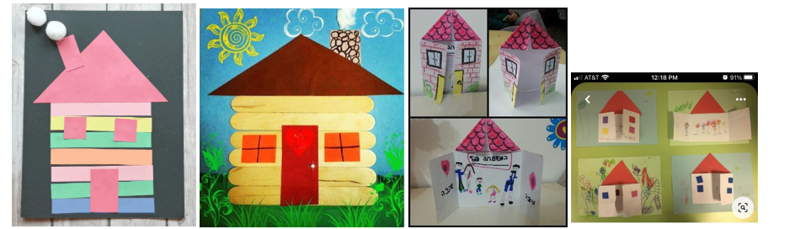

Week 2 : Safety

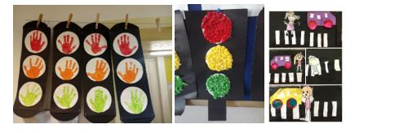
Week 3 : My family

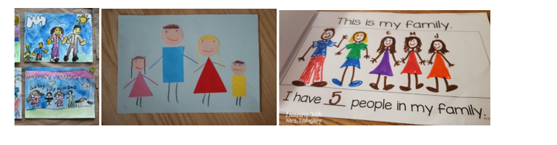

Week 4 : The Weather

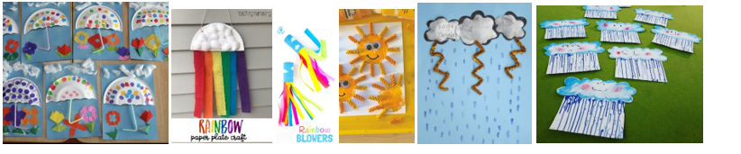

Week 5 :Autum

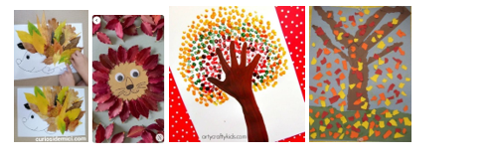
Week 6 : Sounds

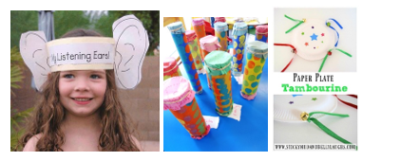

Make your own "shaker" or musical instrument from recyclable material. Listen to the sound it makes. Can also use paper plates and make a tambourine.

Week 7 : Sight :

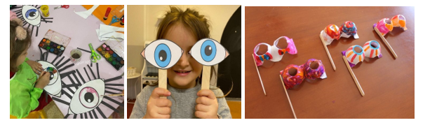

Week 8 : Touch

Finger painting activities, draw a hand and stick a different texture on each finger. Dip hand in paint and describe the texture of the paint. Print your hand on paper and then stick items of various textures on the hand after it dries. Make a texture collage where learners paste various materials. They can feel the pictures and then describe each texture.

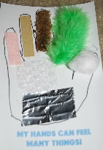

Week 9 : Taste and Smell

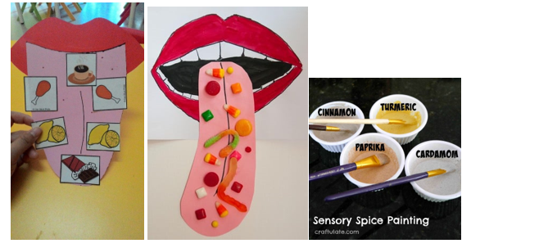

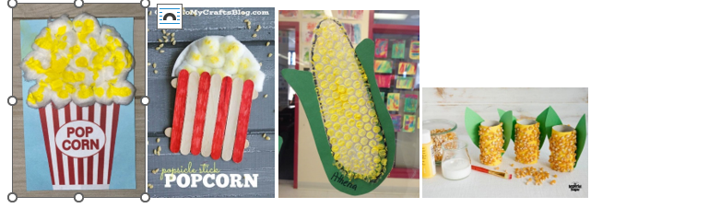

Paint with spices, to get the smell. Make a popcorn picture with cotton wool, to match the smell and taste.

Week 10 :

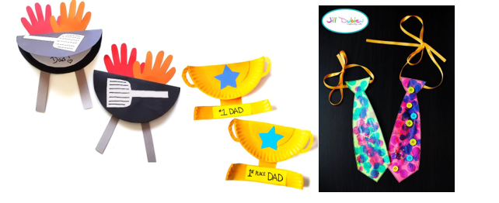

Father's Day- make a card for dad (look out for single parents)

Freedom Day :

